For details about the potential amendments to the *Cosmetic Regulations*, please consult the notice to interested parties.

The questions below have been prepared to guide your feedback.

Once completed please submit your response and any other feedback by email to: [hc.cosmetics.sc@canada.ca](mailto:hc.cosmetics.sc@canada.ca)

**Questions for stakeholders**

General questions:

1. Before purchasing a cosmetic product, please indicate whether you check the product’s list of ingredients and why?
2. What benefits or disadvantages do you identify with regard to the disclosure of specific fragrance allergens (see Appendix 1) on labels of cosmetics?
3. Health Canada is exploring options regarding how fragrance allergens could be disclosed on cosmetic product labels. For example, in the European Union, fragrance allergens are disclosed within the ingredient listing:

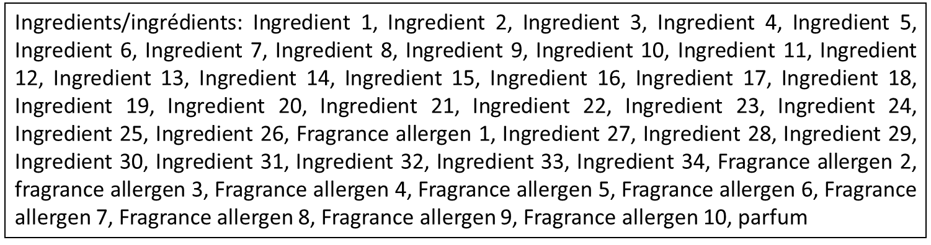

* 1. What are the advantages and disadvantages that you can identify with the option of disclosing fragrance allergens as part of the ingredient list?

Another option is to disclose fragrance allergens separate from the ingredient list, for example: 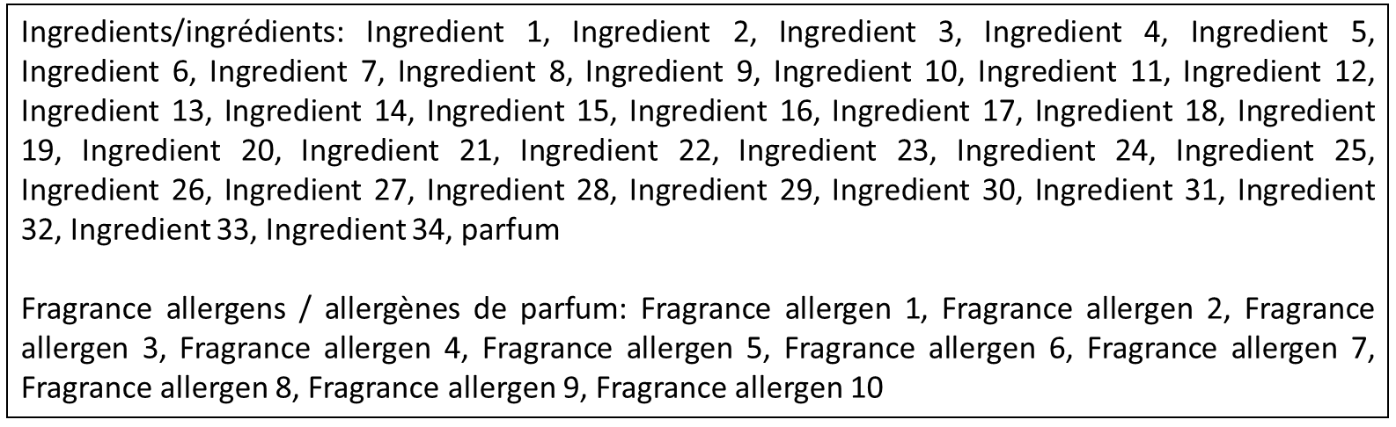

* 1. What are the advantages or disadvantages that you can identify of disclosing fragrance allergens in this way?
  2. What are some other possible alternatives or formats to disclose specific fragrance allergens on the labels of cosmetics, along with their advantages and disadvantages?
  3. What is your preference for how specific fragrance allergens should be disclosed on the label, and why?

1. When the immediate container of a cosmetic is too small to accommodate the disclosure of ingredients directly on the label, this information can be made available on a tag, tape or card that is affixed to the container. Health Canada is exploring options for off-pack labelling of ingredients and specific fragrance allergens for cosmetics in small packaging. For example, an alternative approach for small packages could be to direct the consumer to a website where they can access the required ingredient information (including the presence of specific fragrance allergens):



* 1. What are some alternative options for the off-pack labelling of ingredients for cosmetics in small packages, as well as the advantages and disadvantages of each?
  2. Considering that not all consumers may have internet access at the time of purchase, what are some alternative ways that the required information could be made available in the case of small packaging?
  3. What is your preference for how specific fragrance allergens should be disclosed for cosmetics in small packages, and why?

1. Do you have other feedback or comments on the other changes being considered for the *Cosmetic Regulations*?